**Springboard Software Engineering**

**Section 29: Capstone Project 1**

**Soccer App Project Proposal**

**Design goals of the website**

The aim is to satisfy the craving for knowledge about soccer; both historical and also ongoing and forthcoming events.

The objectives are to be informative, factual, analytical, fun and interactive.

To begin with, the focus will be on the English Premiership and, if feasible, it will be extended to other leagues and countries.

The ambition is to go beyond the factual and statistical by widening the offering to include newspaper/internet articles and video highlights of recent games. There will also be a push element to the app with emails being sent to users containing links to recently released news, scores of ongoing games and highlights.

Graphical analysis is also intended to be offered. For example, showing a team’s end of season achievement on a number of metrics over a defined number of seasons. The metrics could be, for example, final position, goals for/against etc. Other teams can be selected for comparison purposes.

There will also be a social aspect to the app. Users will be able to add a brief bio about themselves that other users can see. It is also planned that a comments section is created allowing users to post views on a range of subject matters connected with soccer.

Users will also be able to enter their ‘Start of Season Predictions’ for the top and bottom league table positions and managerial dismissals. These will be available for all to see and will be saved for future viewing.

**Demographics of visiting users**

The only demographic is those that are interested in soccer; those who wish to study facts, but are also interested in the up-to-date breaking news stories about their sport and are open to posting and reading the views of other users. They will be interested in the data and insights and involved by being invited to add their comments and predictions.

**Outline of the data to be used**

For information, the API that will be mostly used is: <https://apilist.fun/api/the-sports-db>

Much of the data is already provided by the API. However, some links are chargeable and so other APIs will be sought where necessary.

At a high level, data will be:

* Club information
* Fixtures (past and present)
* Team news
* Current scores
* Analysis and statistics on games; results, final league positions
* Results
* Video clips of highlights
* Breaking news stories associated with the user’s subjects of interest

**High level project approach**

**Database schema**

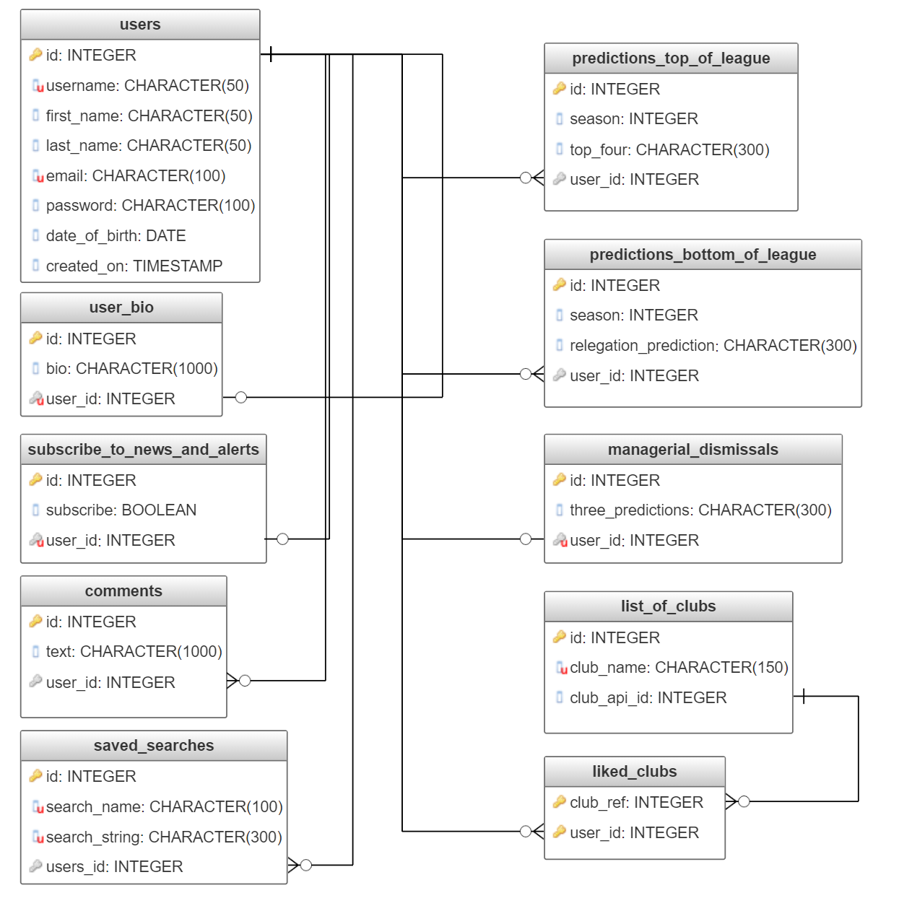

**Potential issues with the proposed API**

The main API is a mixture of free and paid-for content. Some of the functionality that it is planned to be offered crosses the line into the paid category, for example video highlights and live scores. It is envisaged that other APIs will be used for these requirements

**Security of sensitive information**

Passwords will need to be secured. This will be done using the bcrypt hashing function with a flask wrapper. An encryption function will be called on account creation and then an authentication function each time the authenticity of the user needs to be verified. The user id will be saved in the session upon login and deleted on logout.

A comments section is planned. It is important to be conscious of maintaining an acceptable level of behaviour and avoid abuse. A starting point is a published standard of behaviour that all users must accept at the point of registration. Ideally, every comment should be assessed to ensure it meets the standards, although this seems impractical. Functionality should be available for users to flag what they consider to be abuse.

**High level user flow**

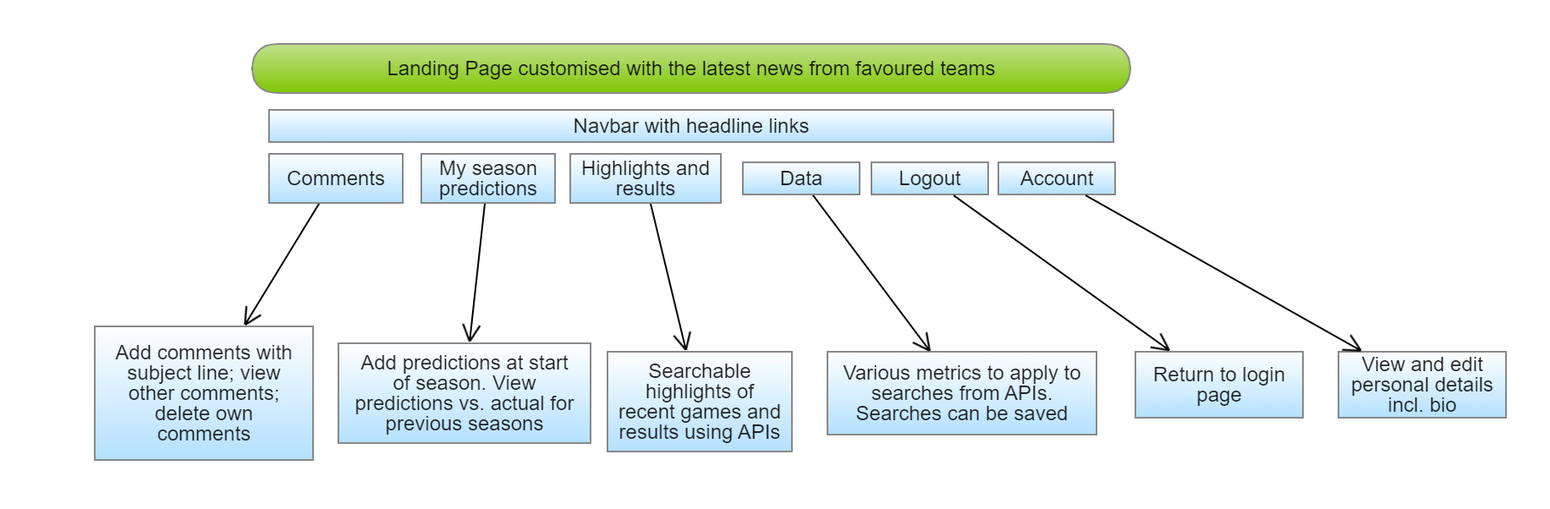

**Features over and above the usual database CRUD**

A comments section will allow for interactive involvement of users. They will be able to add/delete comments, view those of other participants and also like comments.

It is intended that graphical analysis is added to present data against time or other teams for a more visually stimulating and understandable experience.

Offering video highlights of recent games will be a challenge in that it may involve additional technologies other than those used for the simple retrieval of data from a database.

In addition, adding recent news articles, customised to user preferences, will also involve a different test in terms of finding the source(s) of such articles, filtering according to user-defined criteria and understanding how to stream or download these to the web site.